The dataset is being collected from kaggle and is about the number of cycles going over bridges in new york city. I have created three visulization and it interprets my results as below.

**Dataset link: https://www.kaggle.com/datasets/new-york-city/nyc-east-river-bicycle-crossings**

**Github repository link:**

**Scatter plot for relationship between daily precipitation and total traffice:**

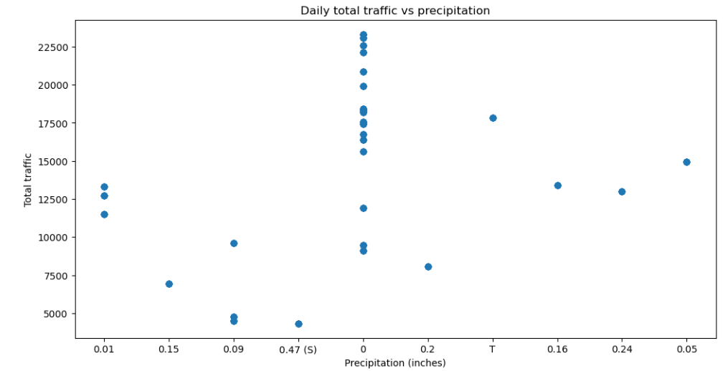

Fig1

The scatter plot (Fig) illustrates the correlation between two variables, daily precipitation and daily total traffic across the four bridges in New York City. Each dot on the plot corresponds to a single day data in which the x-axis indicates the amount of precipitation on that day and the y-axis representing the total number of vehicles that crossed all four bridges. The scatter plot indicates that there is no definite linear relationship between daily precipitation and daily total traffic. Some days with high precipitation have low total traffic while other days with similar precipitation have high total traffic. However, there is a general trend indicating that as precipitation increases the total traffic tends to decrease.

**Bar graph for Average daily high temperature in Fahrenheit for each month:**

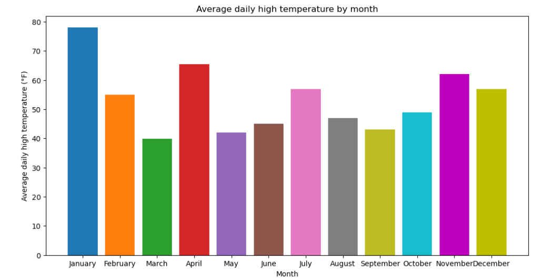

Fig 2

The bar chart in (Fig 2) displays the average daily high temperature in Fahrenheit for each month of the year. The x-axis denotes the name of each month and the y-axis represents the average temperature in Fahrenheit. The bar chart enables us to compare easily the average temperature between different months and observe any seasonal patterns in the temperature.

**Line graph for representation of traffic volume on bridges:**

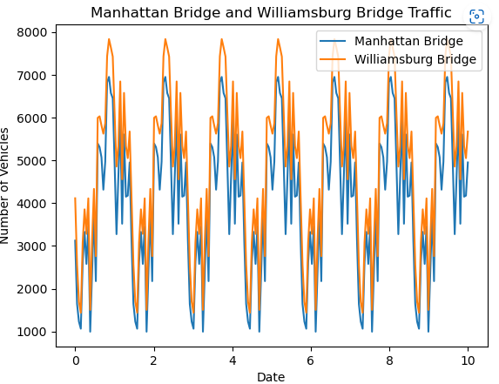

Fig 3

The line graph in (Fig 3) illustrates the traffic volume on Manhattan Bridge and Williamsburg Bridge over time. The blue line represents the traffic volume on Manhattan Bridge, and the orange line represents the traffic volume on Williamsburg Bridge. By analyzing this graph we can detect the trends and changes in traffic volume over time for both bridges.